The file "example1.html" contains:

- script includes for the kernel
- script includes for 3 kinds of parts - constructor functions for schematics, file selectors and text output boxes
- a <body> that defines a top-level <div> called topLevel, and 2 components: (1) part1 (a file selector input widget) and (2) part2 (a text file output box (an HTML <p>).

This corresponds to Fig. <$n:figure:Example1>.

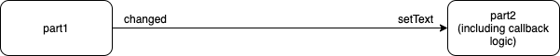
Fig. <$n:figure:Example1> Example1.html as a Diagram

Fig. <$n:figure:Example1> is almost the same as Fig. <$n:figure:FirstCut>. The pin names have been changed.

